

**e-Yantra Robotics Competition - 2019-20**

**Implementation Analysis: Construct-O-Bot**

**#1598**

|  |  |
| --- | --- |
| **Team leader name** | Nashrah Naseem |
| **College** | Jamia Millia Islamia |
| **Email** | nashrah1304@gmail.com |
| **Date** | 1112-1-2020 |

**a. State the scope of the theme assigned to you.**

**(5)**

It’s an honour for us to be a part of e-Yantra Robotics Competition 2019-20. The theme of our project is to construct ‘O-BOT’. Our team has made an O-Bot which can transport heavy items along with other materials as sand, cement etc. at construction sites. It can transport single or multiple items at a time placing the material at the required positions which may include placing the material at different heights. After receiving the command, it coves the shortest distance and protecting itself from various obstacles. It provides wide range of scope from preventing loss of human lives and property to tackle hazard environmental conditions by replacing humans. Motivated by this, our project will be helpful in reducing the losses and can protect precious human lives as well as the economy.

We would like to thank e-Yantra for giving us this opportunity as well as a platform where one can serve mankind through such projects

**b. Upload the Final Arena Images as per configuration given in the rulebook.(5)**

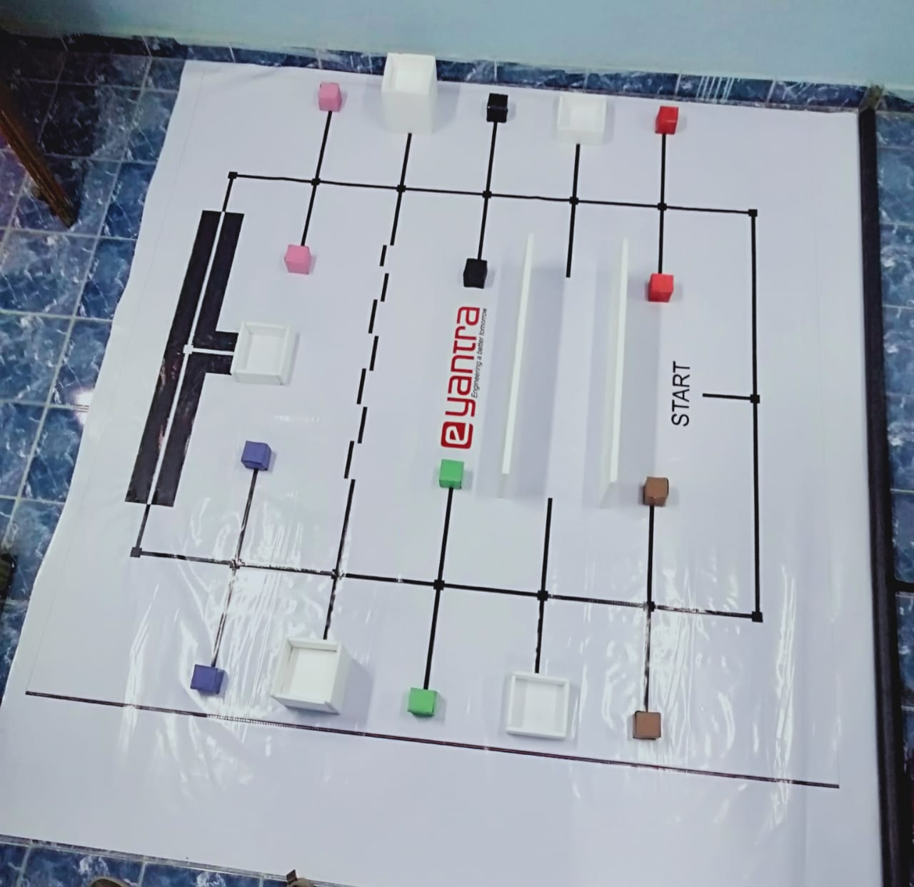

**c. Team have to design a robot to solve the problem as mentioned in the rulebook. Attach the final robot design in the answer. Why have you come up with such a design? (20)**

**Componets:**

**1. Dimension of Chassis:** 15cm*17cm

**Reason:**We took this size because we have calculated the arrangements of all the components and it came around this size.

**2.DC Motors placement:** on back side of chassis with its axis at the bottom

**Reason:**

So that the height of the bot will get reduced that will increase our accuracy of IR sensors .

**3.Castor wheels placement:** In front of chassis

**Reason:**

To make chassis at equal level from the ground further to increase stability .

**4.IR sensors placement:** at the middle of front bottom of the robot and its above 1cm of the ground.

**Reason:**For more accuracy of following track and to make our bot remain at the center of the track.

As because IR sensor does only have a accurate reading between 9mm to 3cm.

**5.At-mega and Battery placement:**

At-mega is placed 3cm above the chassis. Battery is placed just below the atmega board.

**Reason:**

Atmega is above to protect the pins and terminals from tangling and heating effect and also to make easier

connection of battery with atmega.

**6.LCD placement:** on left side of battery.

**Reason:**

1.There are many connections involved in LCD with atmega that narrowed its position around it

2.And because no other component will overlap on it i.e arm handle wouldn't stop the sight of display.

**7.L298n Motor driver placement:**Front of the chassis

**Reason:**

As wires of DC motor are too long placing motor driver at the front makes connecting them in a neat manner .

**8.Sharp sensors placement:**Both are kept at a 6cm height from chassis at middle of the Acrylic sheet with dimensions with 10*6.5cm. It is made connected with servo motor on both the sides of the arm base that it remains stable.

**Reason:**

Because as the sharp sensors works more accurate within range of 10cm to 80 cm. And distance between the walls is 30cm so in order to make it to the range we have to place it in middle.

**9.ARM placement:**above 10cm from the chassis at the center.

**Reason:**

For balancing the center of mass of the complete robot .

**Functionality:**

**Power distribution:**

as we have to make a system for power distribution, but we made a connection through soldering wires in

AVR connection pin of battery for power distribution.

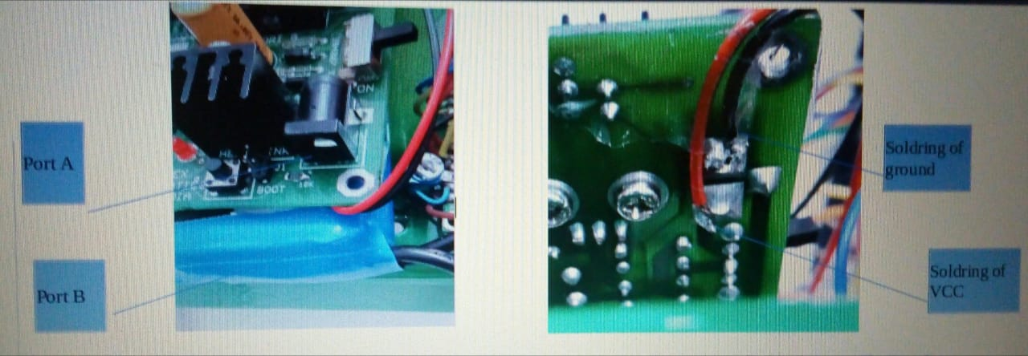

**Reason:**As because it minimizes the connections we have made the connection through the AVR directly.

**Arm function:**

We use two servo motors. Servo A uplifts and down-lifts the handle and servo B stretches the strings

used to close the grippers.we place arm in frint middle of the chasiss above 4 cm above the chasis and the handle is o the right or left side of the chasis as shown in figure. Due to this our arm has not move to the warehouses path or constructing material due to this time will be saved .

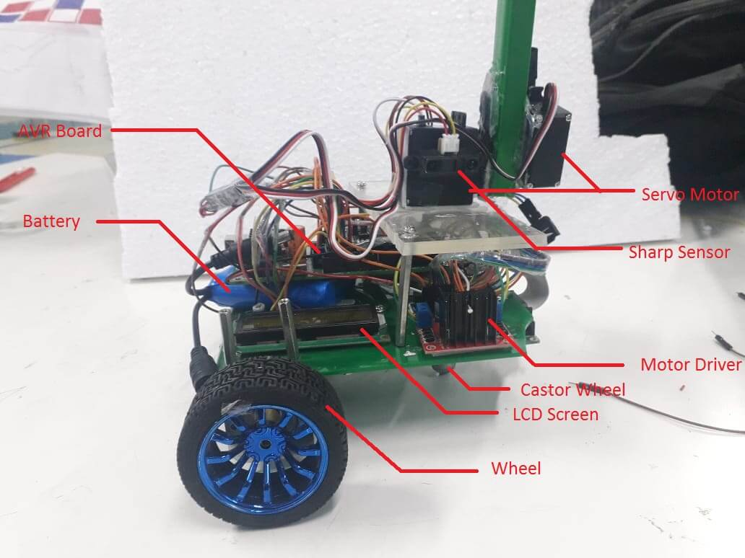

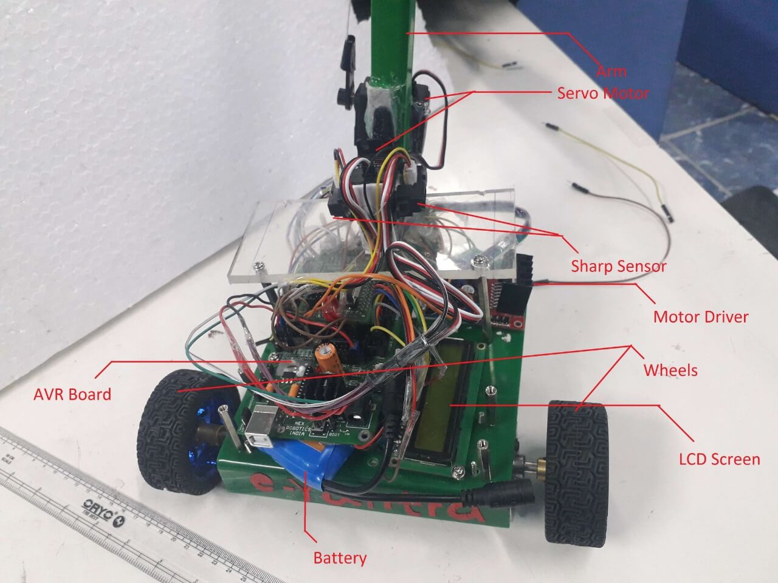

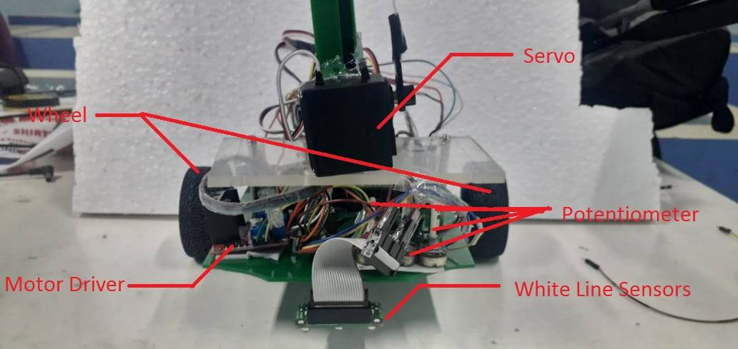

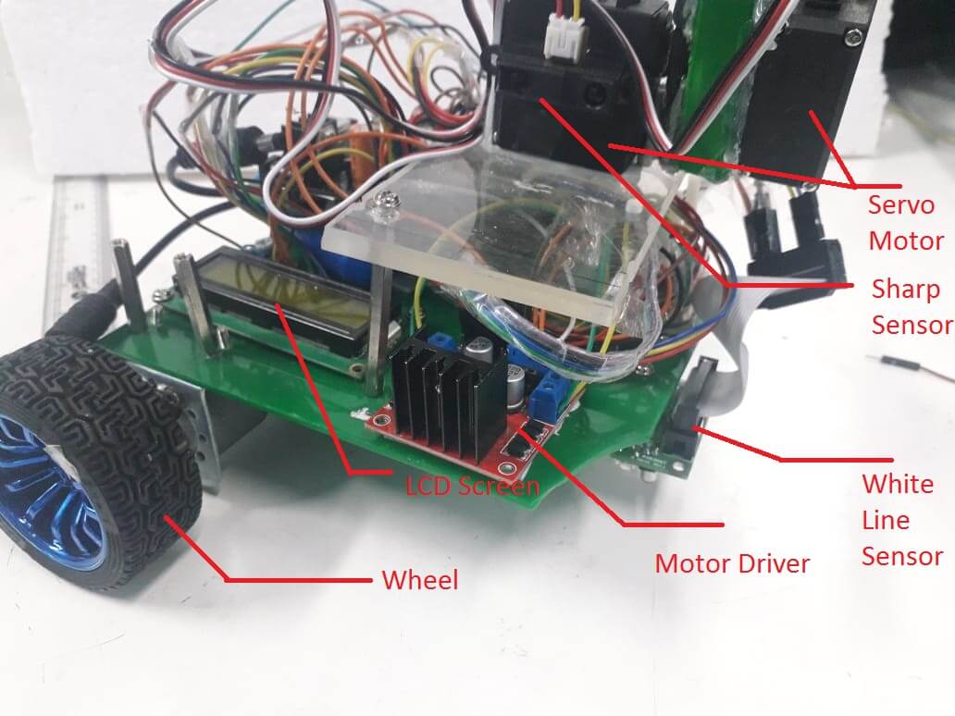

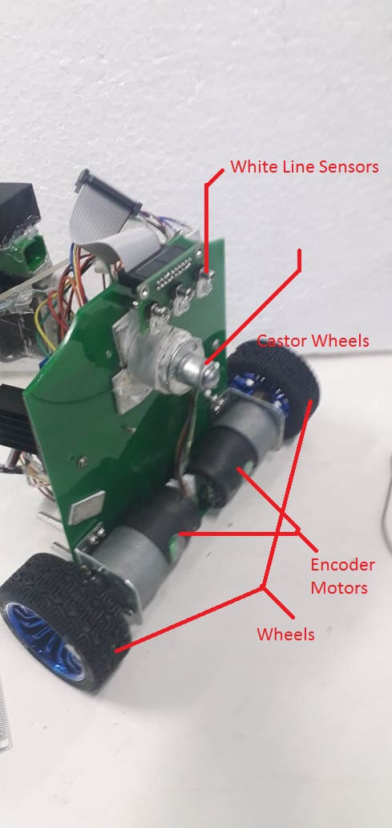

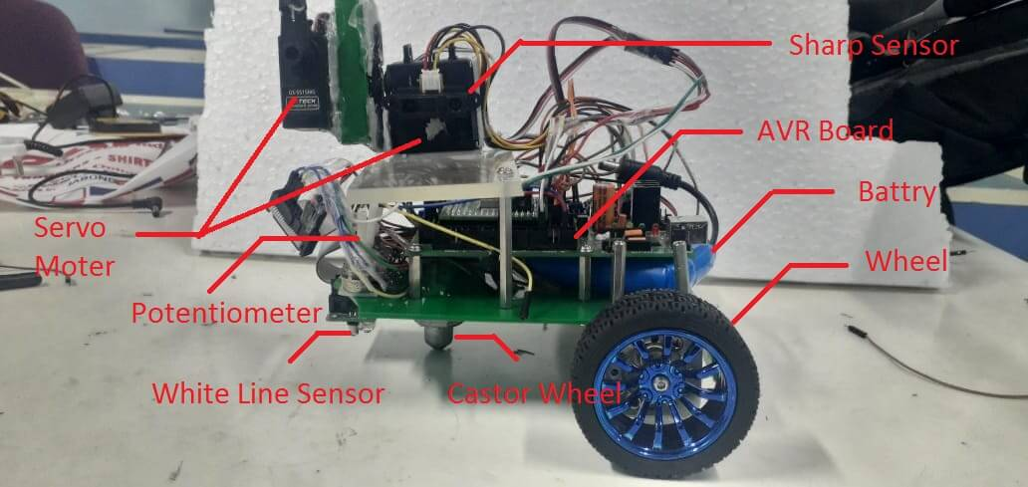

**d. Using the designed robot, make it move by 10 cm forward, 10 cm right, 10 cm left and 10 cm backward. (15)**

https://youtu.be/pgXonmAiSTM

**e. Identify the major components pr ovided to you and explain the role/purpose of each component that is required for designing the robot for the theme. (5)**

**Major Components used are as following :**

**Electronic Systems**

**component 1:-LCD:**

Liquid Crystal display is a flat panel display that uses the light modulating properties of liquid crystals combined with polarized. LCD s can either be normally on(positive) or off(negative) depending on the polarized arrangement.

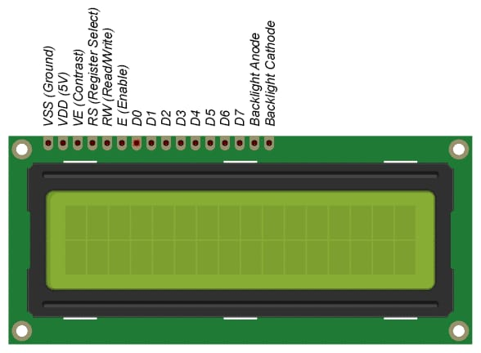

**Function:-**use to display inputs and clear understanding of the scenario .

**Use in the theme:**

1.debugging our algorithm .

2.For displaying our sensors reading and detecting node.

3.to show the start and stop .

**Component 2:-Proximity Sensor:**It is an electromagnetic device which gives the distance of objects using IR light.Using one or more proximity sensor an bot move avoiding any collision with dynamic or static objects.

**Use in the theme:-**

we use in the theme for moving the robot in the straight line within the wall.

**Component 3:-STK 500:** It is a development system for Atmel AVR flash micro-controllers. It interfaces with AVR studio for burning of code and debugging.

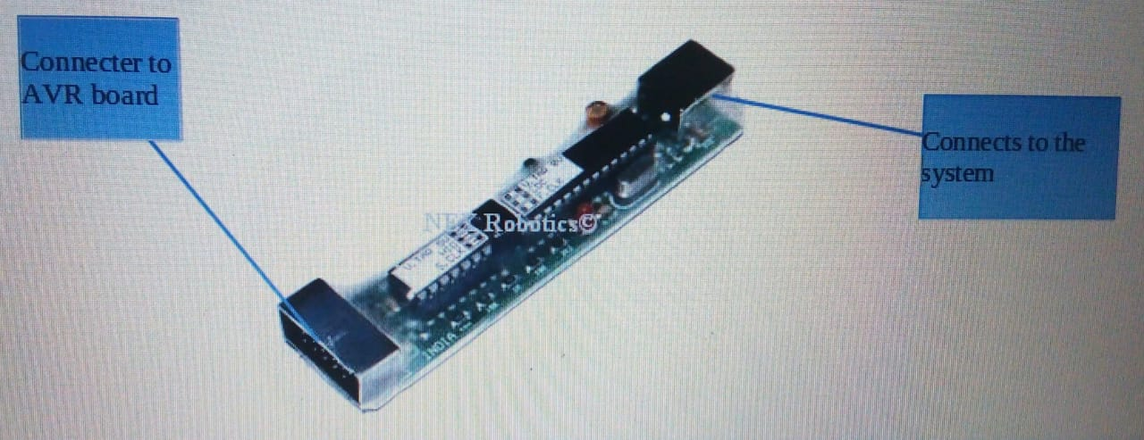

**Function:-** It is a device which helps us to test our program through micro-controllers, it generates

controls signals and modulates the clock speed .There are three jumpers in it, J1, J2, J3.

J1 is for providing supply(5V), J2 is to enable and disable USB CDC and USB HID mode, while J3 is used for enabling slow clock speed around32Khz to 1Mhz.

**Use in the theme:-**

we used STK500 as medium to send code, programmed in Atmel studio6.2 to AVR development board.

**Component 4:-buzzer module**

**sound system function:-** it converts electrical energy into sound energy.

**Use in theme:-**we use buzzer for indicating the end of the task .

**Component 5:-White Line follower sensor:**

the sensor works by detecting reflected light coming from its own infrared LED(transmission), by measuring the voltage level of reflected infrared light (receiving).

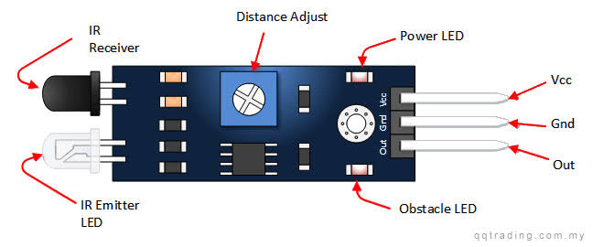

**Function:-**as it provides reflected light we can find the color(In white line sensor it only detects black or white , if the body reflects or not) by measuring the amt of reflected light.

**Use in the theme:-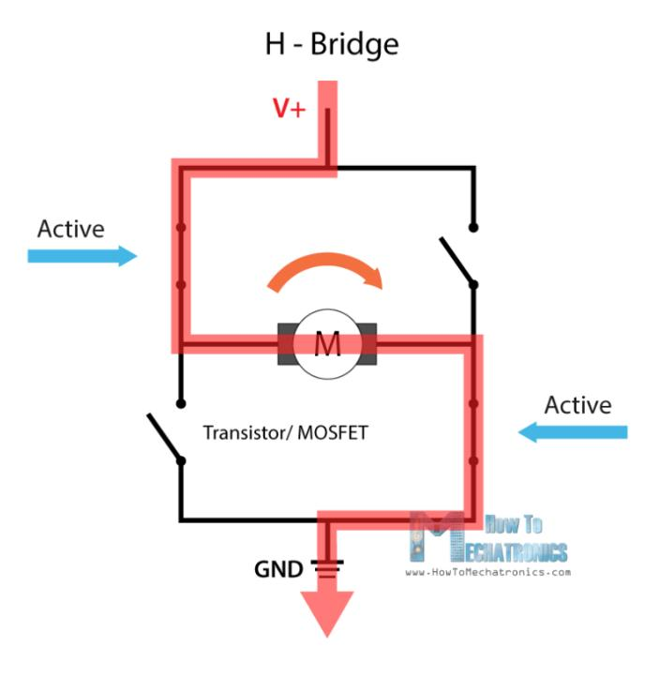­**

we use it as a guider to our bot for following of the path such as white line path,black line path,zig-zag path ,to take left ,right,stop etc. by calculating its reflected light by the path .

**Component 6:-l298n motor driver.**

It is an intregated monolithic circuit electronic system . It has 15 pins ,dual full bridge driver .it use stantard logic signal to control . It adopts high capacity filter in the circuit that protects device from being damage by the reverse current of an inductive load and enhancing abilit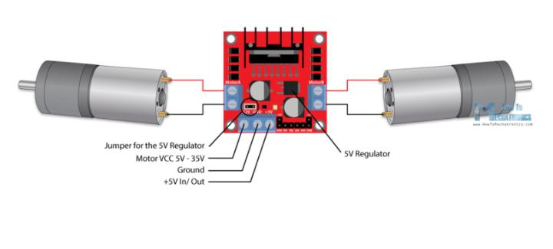y.

**Function:-** to allows speed and direction control of two dc motors at the same time.

**Range:-** dc motor which have voltages between 3.2-5 to 35-40v can be used in l298n motor driver.

**Use in the theme:-**we use to control dc motors of the bot such as start, stop, left , right, forward, backward, as per the control logic.

**Component 7:-Atemga :**

Atemga is a development board with 11 ports named from A to K with 10pins each except ISP(In system program ) pin which contains 6pins, with all male heads .

Microcontroller: ATMEGA2560 with 14.7456 MHz crystal

* Power: 7 to 15V, AC or DC, Heat sink on 7805 for better current rating
* Reverse polarity protected
* [2.4GHz ZigBee wireless module adaptor](http://www.nex-robotics.com/products-topmenu-45.html?page=shop.product_details&flypage=flypage.tpl&product_id=197&category_id=12&option=com_virtuemart&Itemid=45)
* 2x16 Character Alphanumeric LCD
* True USB to Serial converter at compatible with CMOS / TTL levels
* Connector for 8 servo motors
* Temperature Range:– -40 ° C to 85 ° C Industrial

32 general purpose working registers, Real Time Counter (RTC), six flexible Timer/Counters wit compar modes and PWM, 4 USARTs, a byte oriented 2-wire Serial Interface, a 16-channel, 10-bit ADC with optional differential input stage with programmable gain, programmable Watchdog Timer with Internal Oscillator, an SPI serial port

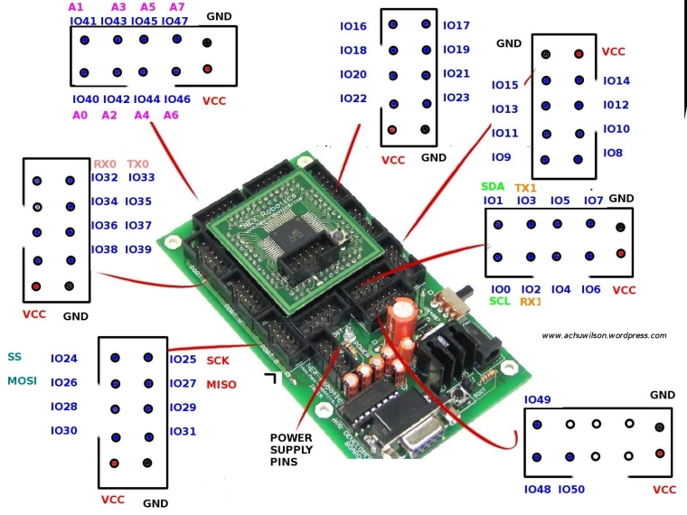

This microcontroller basically functions on embedded C language with a range of 7V to 15V and contains various other functional units like Zigbit port, heat sink ,DC input, USB port etc.

**Use in our theme:-**

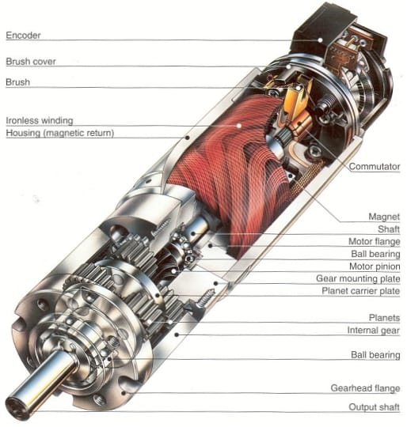In short ,It is used for embedding our programmed algorithm to function like a control system of and control all the sensors provided by e-yantra.

**Mechanical Systems**

**Component 8:-DC Motor with encoder:**

A DC motor simply works on the principal of produced torque(Force) on an current carrying conductor when placed in magnetic flied .

**Use in the theme:-**

In our case this torque makes the wheels rotate. A DC motor with encoder helps us to know the RPM of the motor(wheel in our case) .Thus speed and distance can be calculated from it. RPM is calculated by the help of encoder, which counts the number of times each shaft passes by, by giving 1 and 0 for corresponding values.

**Component 9:-DC Servo Motor:**

These are rotating devices which rotates accordingly to the programe encoded.Servo motor have a 180 degree movement (unless no modifocation is done).The movement is contolled by the help of PWM(pulse wave modulation) which countinously keep sending electrical pulses.

**Fuction:-**it rotates 180 degree (the servo motor which you provided us).

**Use in the theme:-**

we use servo to rotate the arm for up and down motion.

Second servo motor is used for the rotation of the gripper(open and closed form).

**f. Explain the components that you will be using to design the robotic arms and its working for the theme. How the arm will be mounted on the robot (left, right, back, front) , also justify your mounting strategy.**

We use the following components in making of robotic arm:-

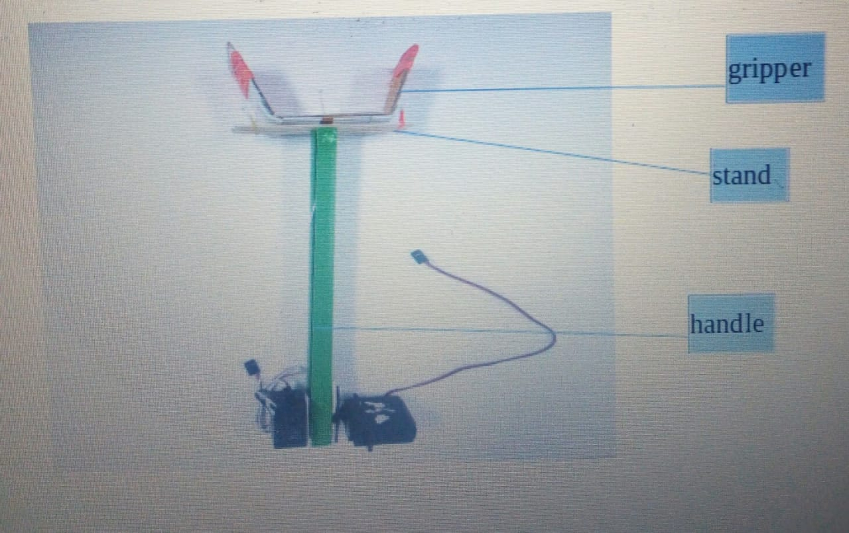

**(we have labeled diagram and then placed the picture here so that our placement of boxes and lines to change in different systems)**

**Component 1:- Cubical** rode made of plastic of length 1.9 cm,width 1.2 cm and height 31cm.

**Uses:-**we use it to make the handle of the robotic arm. we use it to place server motors (both motors)on it.

**Component 2:-**Ice-cream sticks.

**Uses:-**we use it to make stand of robotic arm with the help of ice cream stick which are join together .

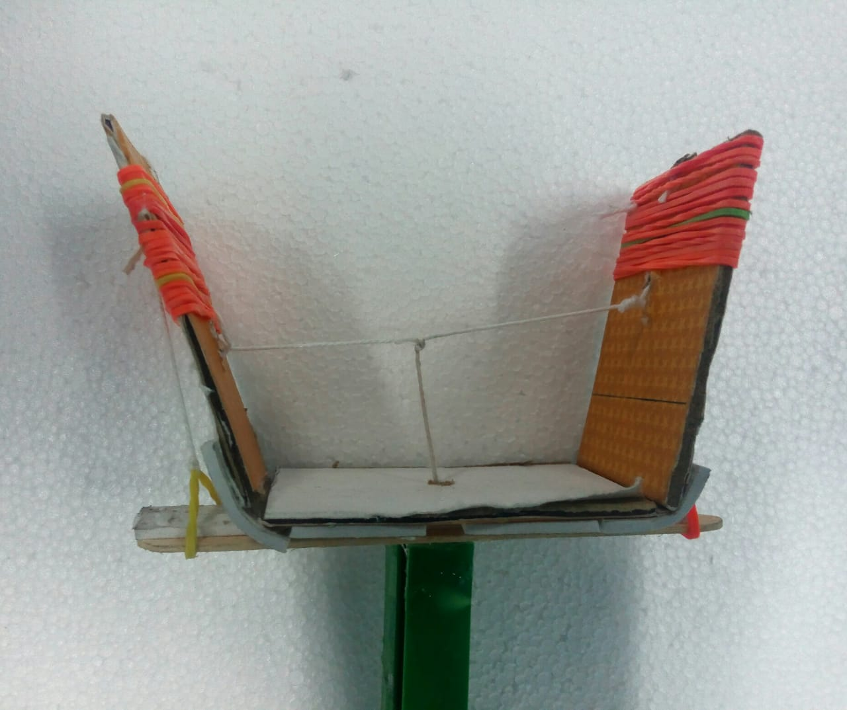

**Component 3:**-card board.

**Uses:-**we use it to make the gripper of the robotic arm.

**Component 4:**-Server motors(2).

**Uses:**we use one motor(B) to control the gripper. The other motor (A)is used to control the up and down motion of the robotic arm.

**Component 5:**-thread

**Uses:-**we use thread to join the two cardboard so the on stretching the thread by server motor ,provide essential force to the gripper to hold the constructing material.

**Component 6:**-rubber band.

**Uses:-**we use it to provide grip to the gripper. We use it to provide restoring force to the cardboard to unhold the constructing material.

Construction:-we divide the robotic arm in three major parts:-

1. handle
2. stand
3. gripper

**1.Handle:-**handle is the lower part of the robotic arm. It provides length to the arm. The two server motors are attached on the handle at the end so as to increase torque.

torque=perpendicular distance from the axis force*force

**2.Stand:-** Stand is connecting media between the handle and gripper .There is hole in the middle of the stand for crossing of the thread. It is made up of two ice-cream sticks join together.

**3.Gripper:-**Gripper is made up with help of three cardboard pieces is of cardboard of size length 5cm,breadth 2.5cm(1and 2)and third cardboard has length 7cm ,breadth 2.5cm.The two cardboard is attached side by side to the third cardboard with help of double sided tape as shown in the picture.

The 1,2(mention in the picture) cardboard are attached with the help of thread (H) and another thread (S)is attached to the middle of thread(H).Thread(S) is attached to the server motor(B) as shown in the picture.

There are two rubber bands attached to the stand and then threads are attached to the upper part of the cardboard 1 and cardboard 2 respectively to provide the enough restoring force to release the CM from the arm.

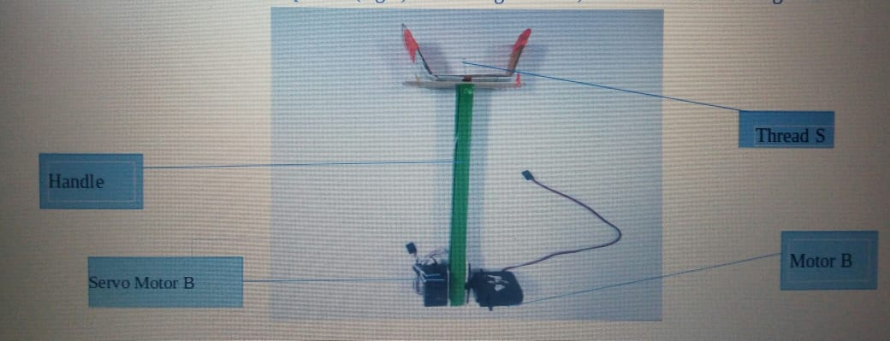

Working:-

**Picking mechanism:-**  suppose we want to pick an object ,we move the robot up to that distance of the arm .Now in order to pick the object we rotate server motor A in clockwise direction to move it down as shown in the figure

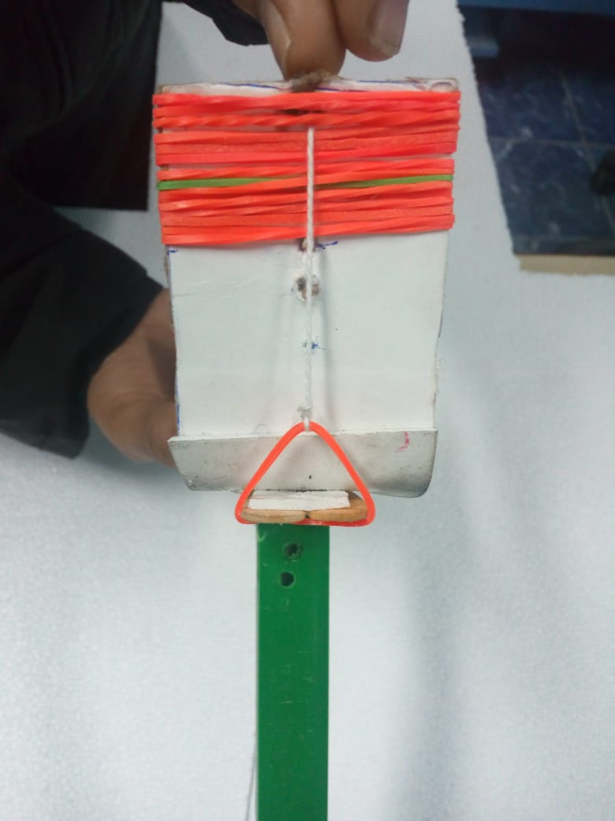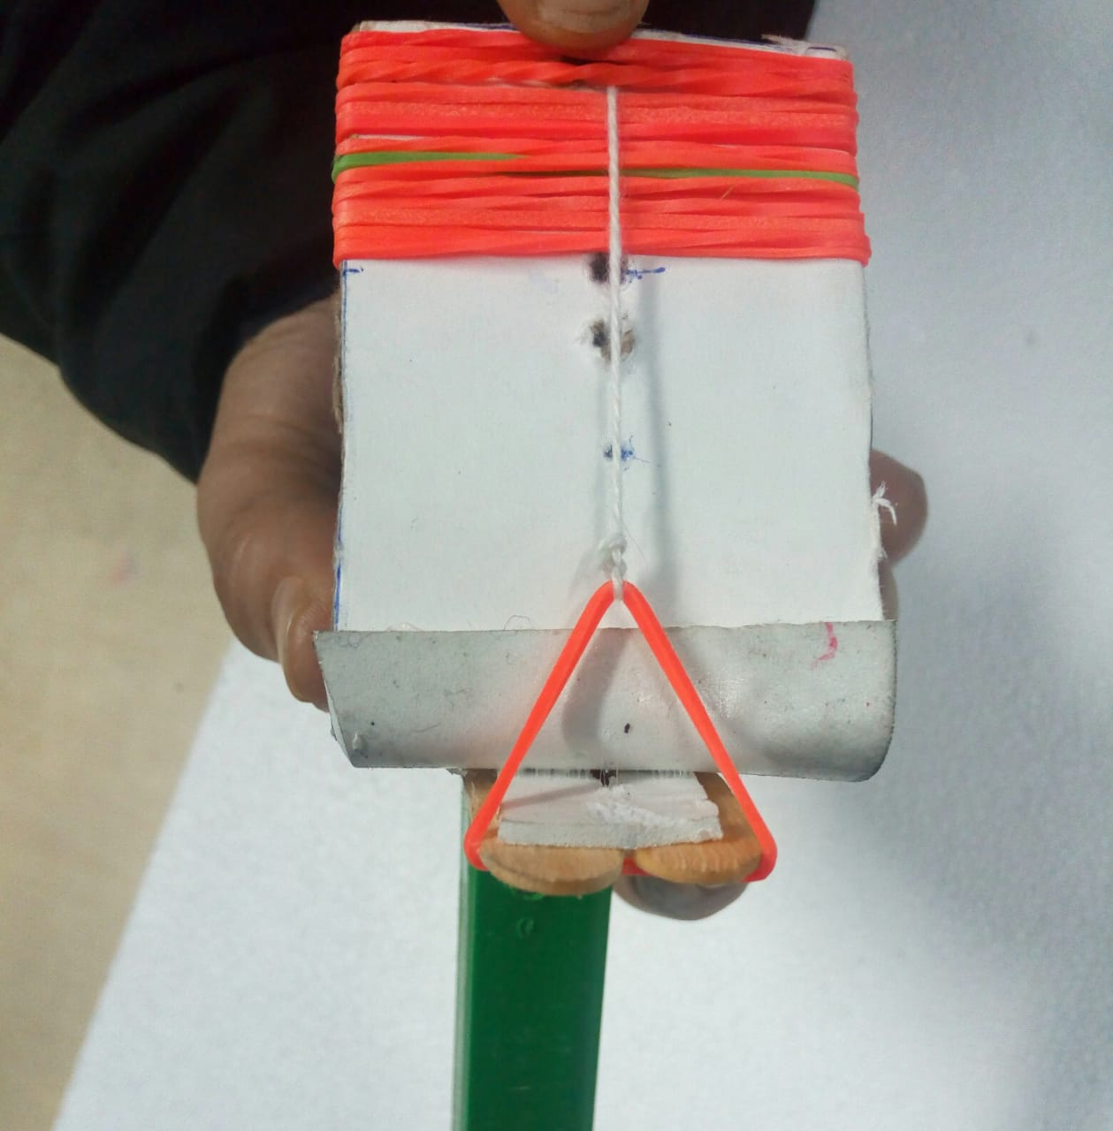

before after

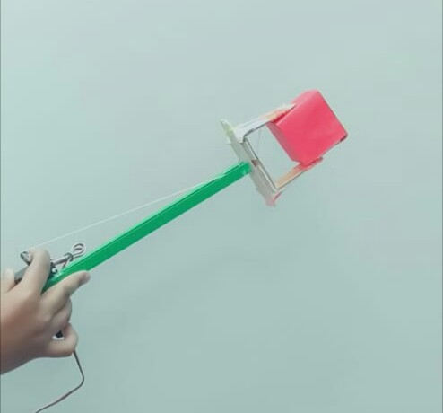

Now, we rotate server motor B in anticlockwise direction, which stretches the

thread S due to that thread H comes closer as shown in the picture . This is how it

holds (pick)the constructing material .

Now rotate the server motor A in anticlockwise direction to move it up and now move to that place wherever you have to place

**Placing mechanism:-**In order to place ,rotate the motor A in clockwise direction up to which height you want to place ,now rotate the server motor B in the0 clockwise direction so that the thread will go back to its original position and the thread which is attached to stand stretch is (restoring force).Now the gripper opens and the box will be placed as shown in the figure.

**ARM PLACEMENT ON THE ROBOT :-**

We placed the robotic arm in the front of robot at the height 10cm above the ground as shown in igure.

**Reason for placing :-**

To balance the center of mass of the robot (to make it stable)as in our design battery and motors are at back side of the robot . Not to move more forward for picking or placing of constructing material.

**g**. **What are the challenges would you expect to face while designing the robotic arms to pick and place the Construction Materials and how will you overcome them? (5)**

The most challenging face for us in making robotic arm with the help of two server motors are as follows:-

**Challenge 1:-**to make gripper(picking mechanism)

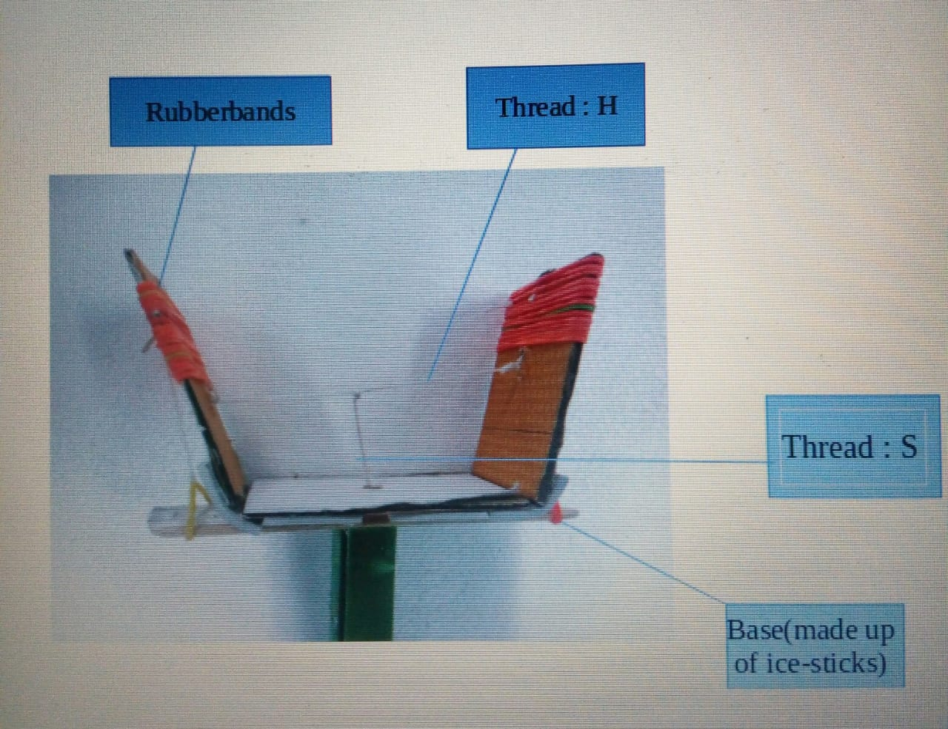

**Solution 1:-**we threads (negligible weights )attached to the both handle of cardboard and on stretching it starts holding the object .

**Challenge 2:-**to increase grip of the gripper of the robotic arm.

**Solution 2:-**we use rubber bands to create more friction between the constructing material and the gripper .

**Challenge 3:-**to release the object(are un-stretched string by motor does not provide enough restoring force ).

**Solution 3:-**We attached rubber band to both sides of the stand and then join threads between the ru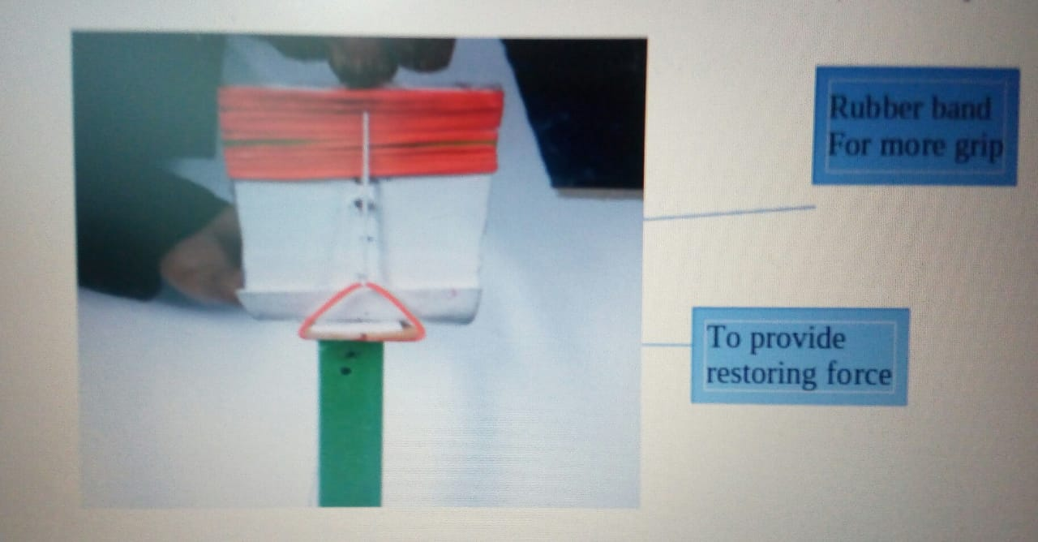bber band and the cardboard 1,cardboard 2 respectively

**Challenge 4:-**placing of server motors on the handle so that to get more torque.

**Solution 4:-**We placed both server motors at the end of the handle so that more torque will be get.

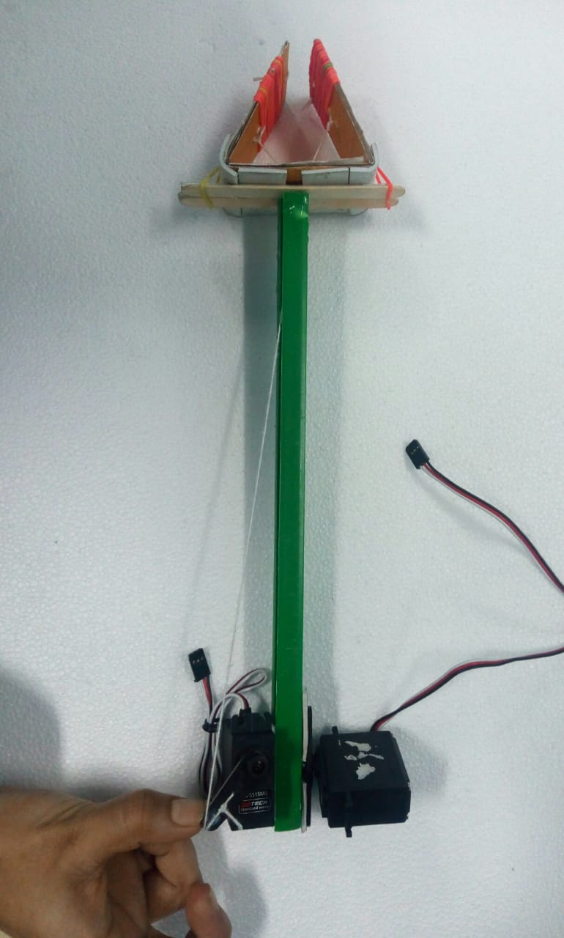

**Challenge 5:-**Material of the handle .In order to make handle we need such material which is light (by weight),rigid ,non flexible .

**Solution 5:-**we use cuboidal plastic (rigid) rod of length 1.9cm,breadth 1.2 cmand height 31cm.

**h. In this theme, we use the following formula as mentioned in Judging and Scoring section of Rulebook:**

**Total Score = (600-T) + (CP*30) +(CD1*80) + (CD2*100) + (WHB*100) + (B*100) – (P*50)**

**What will be your strategy to earn maximum points and Bonus points in a run ( given the following Configuration Table)? (10****)**

|  |  |  |  |
| --- | --- | --- | --- |
| **House** | | **Construction Materials Required** | |
| H1 | low-rise | Brick | Sand |
| H2 | high-rise | Gravel |  |
| H3 | high-rise | Cement | Brick |
| H4 | low-rise | Electrical fittings | Sand |
| H5 | high-rise | Gravel | Paint |

|  |  |  |  |
| --- | --- | --- | --- |
| **House** | | **Construction Materials Required** | |
| H1 | low-rise | Brick | Sand |
| H2 | high-rise | Gravel |  |
| H3 | high-rise | Cement | Brick |
| H4 | low-rise | Electrical fittings | Sand |
| H5 | high-rise | Gravel | Paint |

Our basic Strategy would be to complete the task without any penalty with minimizing the total time in keeping our theme in mind.

As higher rise house gain us more points than low-rise we have decided to prioritize the higher rise first and then lower rise.

If CMs of WHB are placed first it will cost us 100 more points but on the other hand we will loose some of our time. On analyzing this scenario it will come to following equation

P=(600-T1) + C ….(1)

P=(600-T2) + C + 100 …..(2)

[C is a constant same for both the equation and T1 ,T2 are total time taken in both the cases]

So looking at this it can be concluded that if our bot is able to place the H5 CMs under 100 seconds than we will choose to place them first than any other houses.

First we fill h5 house so that we could get bonus points. then we take electric fittings and put in H4 and the again sand in H4 .then we fill the H2 houses .Then we fill H3 and H1 houses as to take the robot less time .

**i. Explain your strategy in following (10)**

**I.Wall,**

**II.Zig- Zag and**

**III.White line**

*Our Strategy for the followings are as follows:-*

*1. Wall :* while our bot have to cross wall, we will be using both proximity sensors .one proximity sensor will be attached on each side of the bot( left and right edges).

just as the bot leaves the track of the black line it will be simply moving in the same direction but the only difference would be that this time proximity sensors will be active. We will call proxy_forward_() function at that time .

there will be the following cases in this :-

Case 1 : In this function when both the reading are equal we let the bot move as it is(no change as the bot will be moving forward continuously).

Case 2 : Either of the reading more or less than at that moment we have made proxy_forward_() function programmed such that it will move soft_left or soft_right accordingly using the if statement under a while condition so that bot keep giving the sensors's reading continuously .Due to this, there would be less chances that bot will crash with the wall and more over as we are making the bot to move soft_left or soft_right, the bot wouldn't stop in between so that it can cross the wall in less time.

*2. Zig-Zag : f*or crossing the the zig-zag path there will be sudden change of the track from(0,255,0) to (0,0,255) or(255,0,0) so at such situation our Zig_Zag() function will simply command the bot to move soft_left (255,0,0) or soft_right(0,0,255) until the bot doesn't get the middle sensor reading equals to black. This can be again done with if statements under a while loop.

*3. White line :* for white line conditions just get reversed as that of black line .As soon bot tracks (255,0,255) our white_line() function gets executed. In this nodes are identified with (0,0,0) and bot is moved forward on receiving (255,0,255) .left and right turns are made for (0,255,255) and (255,255,0).

**j. Draw the complete flow chart of the algorithm used to solve the problem. (15)**

